**TWITTER DATA ANALYSIS**

**IMPLEMENTATION**

**STEP 1: Loading packages and registering Oauth.**

require(twitteR)

Loading required package: twitteR

> require(wordcloud)

Loading required package: wordcloud

Loading required package: RColorBrewer

> require(tm)

Loading required package: tm

Loading required package: NLP

> require(stringr)

Loading required package: stringr

> setup_twitter_oauth(ConsumerKey, ConsumerSecret, AccessToken, AccessSecret)

[1] "Using direct authentication"

Use a local file to cache OAuth access credentials between R sessions?

1: Yes

2: No

Selection: 1

Error in check_twitter_oauth() : OAuth authentication error:

This most likely means that you have incorrectly called setup_twitter_oauth()'

> setup_twitter_oauth(ConsumerKey, ConsumerSecret, AccessToken, AccessSecret)

[1] "Using direct authentication"

**STEP 2: Extracting tweets (date: from 24-02-2016 to 25-02-2016)**

epl <- searchTwitter("EPL", n=100, lang="en", since = "2016-02-24", until = "2016-02-25")

> mufc <- searchTwitter("Manutd", n=100, lang="en", since = "2016-02-24", until = "2016-02-25")

> cfc <- searchTwitter("Chelsea", n=100, lang="en", since = "2016-02-24", until = "2016-02-25")

**Sample Output:**

"PremierLeagueX: Italy keep quiet on future of Chelsea target Conte https://t.co/qDbKIT2eH7 #Soccer #EPL"

[[2]]

[1] "vofnzambia: RT @Zambia: Multichoice Offers EPL, La Liga On Compact https://t.co/MAWc0qQLK5"

[[3]]

[1] "csgo_guru: #EPL continues with another Tier-1 match: @astralisgg VS @TeamVirtuspro!\n\nOVERPASS: https://t.co/cYNuCCqwWE\nCACHE: https://t.co/a7J8WuZ90c"

[[4]]

[1] "OsoBipolar7: RT @alshmlaini: @tjpothuraju @TrollFootball probably if Granada was playing in Epl they will be level with Leicester city"

**STEP 3: Creating data frames and extracting only the Hashtags**

epl_df <- twListToDF(epl)

> mufc_df <- twListToDF(mufc)

> cfc_df <- twListToDF(cfc)

>

> epl_hash <- str_extract_all(epl_df$text, "#\\w+")

> mufc_hash <- str_extract_all(mufc_df$text, "#\\w+")

> cfc_hash <- str_extract_all(cfc_df$text, "#\\w+")

> epl_hash

Sample Output:

[[31]]

[1] "#EPL" "#football" "#twitter92"

[[32]]

character(0)

[[33]]

[1] "#weekender" "#THFC" "#Swans" "#EPL"

[[34]]

character(0)

[[35]]

[1] "#WHUFC" "#SAFC" "#EPL"

**STEP 4: Calculating frequencies of the Hashtags**

epl_hash <- unlist(epl_hash)

> mufc_hash <- unlist(mufc_hash)

> cfc_hash <- unlist(cfc_hash)

>

> epl_freq <- table(epl_hash)

> mufc_freq <- table(mufc_hash)

> cfc_freq <- table(cfc_hash)

> all_tags <- c(epl_freq, mufc_freq, cfc_freq)

**Sample Output:**

|  |
| --- |
| > cfc_freq  cfc_hash  #Atletico #Blues #brunch #cfc #CFC  3 3 1 1 5  #chelsea #Chelsea #football #GaryCahill #Inter  2 3 5 1 1  #Italy #KTBFFH #LFC #nightmare #PFerreira19  1 1 2 1 1  #premierleague #RadioCFC #Saints #Soccer #Southampton  3 1 3 3 3  #spinclasses #theoneshow #WinItWednesday #YR  1 1 4 1 |
|  |
| |  | | --- | | > | |

**STEP 5: Creating wordclouds**

require(wordcloud)

> wordcloud(names(epl_freq), epl_freq, random.order=FALSE,

+ colors="#1B9E77")

> title("\n\nHashtags in EPL",

+ cex.main=1.5, col.main="gray50")

Output:

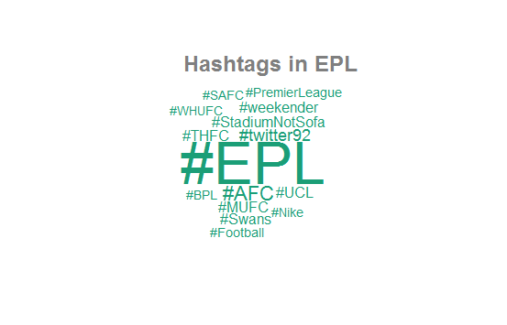

1. wordcloud(names(mufc_freq), mufc_freq, random.order=FALSE,
2. + colors="#1B9E77")
3. > title("\n\nHashtags in MUFC",
4. + cex.main=1.5, col.main="gray50")

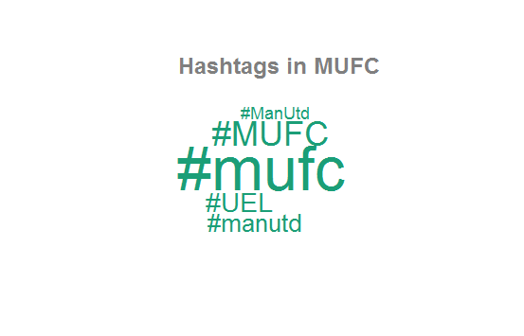

wordcloud(names(cfc_freq), cfc_freq, random.order=FALSE,

+ colors="#1B9E77")

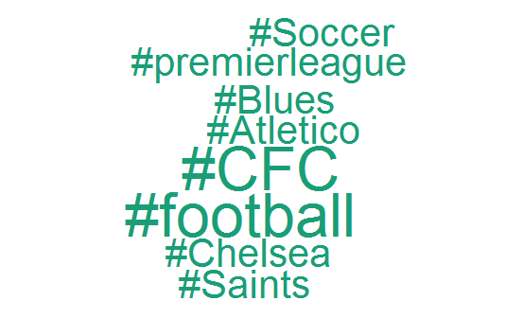

**Aggregate Wordcloud**

# wordcloud

> wordcloud(names(all_tags), all_tags, random.order=FALSE, min.freq=1,

+ colors=cols, ordered.colors=TRUE)

> mtext(c("@EPL", "@MUFC", "@CFC"), side=3,

+ line=2, at=c(0.25, 0.5, 0.75), col=c("#1B9E77", "#7570B3", "#D95F02"),

+ family="serif", font=2, cex=1.5)

>

> cols = c(

+ rep("#1B9E77", length(epl_freq)),

+ rep("#7570B3", length(mufc_freq)),

+ rep("#D95F02", length(cfc_freq))

+ )

>

> # wordcloud

> wordcloud(names(all_tags), all_tags, random.order=FALSE, min.freq=1,

+ colors=cols, ordered.colors=TRUE)

>

OUTPUT:

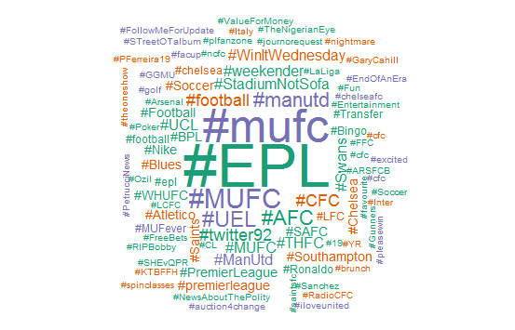

**STEP 5: Creating Bar Graphs:**

require(ggplot2)

> barplot(table(epl))

top5_cfc <- head(mfw_cfc, 5)

> barplot(top5_cfc, border=NA, las=2, main="Top 5 most frequent terms", cex.main=1)

Output:

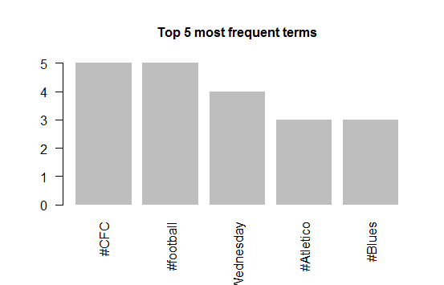

mfw_mufc <- sort(mufc_freq, decreasing = TRUE)

> top5_mufc <- head(mfw_mufc, 5)

> barplot(top5_mufc, border=NA, las=2, main="Top 5 most frequent terms", cex.main=1)

Output:

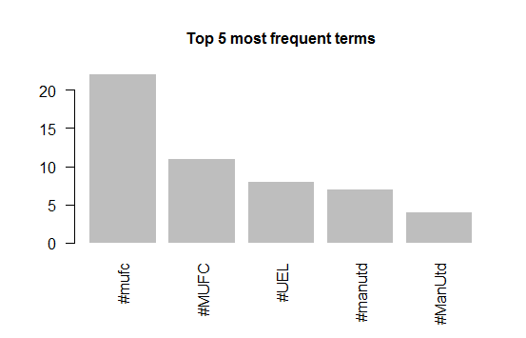

**Overall :**

top <- c(top5_cfc,top5_mufc)

> barplot(top, border=NA, las=2, main="Top 5 most frequent terms", cex.main=1)

> barplot(top, border=NA, las=2, main="Most frequent hashtags from 24-2-2016 to 25-02-2016", cex.main=1)

Output:

